**LESSON FEEDBACK**

|  |  |  |  |  |  |  |
| --- | --- | --- | --- | --- | --- | --- |
| Candidate: David Hiestand | Date: 03.04.2020 | | | | Level: A2 elementary | |
| Tutor: Malcolm Phelps | Course date: CO1/2020 | | | | Length: 45 mins | |
| Lesson focus: Vocabulary / Speaking | TP No.: 7 | | | | No. of students: 4 | |
|  | | |  | | |  | |
| Lesson grade: (at this stage of the course):  **to standard** | | | | | | | |
|  | | | |  | |  | |
| **Overall comments:** Well-done on preparing, delivering and executing an effective lesson that was useful and beneficial for the learners, David. The students were able to engage in your context and use it to understand the use of the target language. You also linked the final freer practice to the context but try to make it stronger in future role-plays that you introduce in class. I was particularly encouraged by the way you monitored the learners and provided useful guidance at the appropriate times without simply providing answers. You also did this in a way that you spread your attention equally between the students and didn’t focus on helping the weakest student only. I can see you are responding to feedback and endeavoring to make improvement in our lessons and teaching techniques. Continue to make improvements in the areas for development listed below. Your lesson was to standard today. I am always impressed by the original material you develop for your lesson. It is contextualized, appropriate to the level and achieves its aims. In this lesson you didn’t use any of the published material. It was all your own original material. You may have discovered a skill here to consider developing in the future. I wish you all the best in your final lesson and look forward to seeing what material you have developed for it this time! | | | | | | | |
| **What worked well in the lesson:**   * **Providing a context for language by means of text, situation or task using visual aids and realia as appropriate (2c):** *a very clear context introduced and maintained to carry the target language throughout the lesson.* * **Focusing on language items by clarifying relevant aspects of meaning and form (including phonology) to an appropriate degree of depth (2e)**: *you covered the MFP to a satisfactory depth for the level of students.* * **Providing appropriate practice of language items** (2g): *both the controlled and freer practice tasks allowed the students to practice the target language in context and at an appropriate level to be beneficial and useful for the students.* * **Monitoring learners appropriately in relation to the task or activity (5j):** very effective monitoring throughout the lesson to react and respond to the students’ needs by providing guidance and not simply giving answers. Good work here. * **Maintaining an appropriate learning pace in relation to materials, tasks and activities (5i):** *through your monitoring and grading of tasks you maintained an appropriate pace to complete all the stages of the lesson without hurrying the students, good.* | | **Areas for development:**   * **Using a range of questions effectively for the purpose of elicitation and checking of understanding (5g):** *better but still room for improvement.* * **Using a variety of techniques in order to give feedback on activities (5h*):*** *remember to provide feedback on content as well as language.* * Using appropriate means to make instructions for tasks and activities clear to learners (5f): ***encouraging improvement but on making these smoother and more fluid.*** * **Ensuring a communicative focus in speaking activities (3b):** *try to expand the communicative focus in speaking tasks to generate more authentic exchanges.* * **Giving an example or demonstration of the task if appropriate (5b):** *you could have provided a demonstration or model when setting up the role-play.* | | | | | |
| **Comments on the plan:** A well-presented plan with generally clear aims (4a) and logical stages (4b) but include clear aims for what you plan to enable the students to achieve and provide a clear context on your cover sheet. Your lesson plan is detailed with a generally easy to follow procedure (4e). You need to include timings (4h) and ensure your interaction patterns (4f) and anticipated problems (4j), with solutions (4k), provide satisfactory depth. A useful language analysis completed (4i) but avoid using the target language in your clarification questions, use phonetic script and show more preparation in you anticipated problems and solutions. You developed effective and appropriate material for the lesson (4c). Once again, well-done. You developed entirely original material including your own audio that you scripted and recorded yourself. You have also prepared them well for classroom. You included an appropriate variety of tasks to facilitate student participation and for the lesson type (4g). Overall, very well-done. Try to provide a fuller language analysis, and addrees problems and solutions for all the stages of your lesson in the future. | | | | | | | |
| A close up of a logo  Description automatically generatedTutor signature: | | Candidate signature: David Hiestand | | | | | |

|  |  |
| --- | --- |
| Stage/Timing | Comments |
| Lead-in  (3:02) | * Situation lead in. * Teacher gives a story about himself: ‘I’m always drinking a lot of water’. * Teacher draws picture on a container: ‘Are you good at drawing?’ * Student: ‘Sorry, more slowly’.: Teacher reforms question and speaks slower: responding to student: good. * Context set. * Instructions given but don’t forget ICQs: students a little confused here. * Another example would have helped. * Students engaged, involved and engaged: good work here. Great student participation for introducing context and activating student’s schemata. * Guiding questions to orientate students to target language. |
| Listening task to orientate students and introduce target language  (5:13) | * Situation set for the listening, good. * You almost forgot your gist questions, but you recovered. * Audio played and students on task. * Example of target language generated and boarded. |
| Language clarification  (9:38) | * Different examples of target language to that generated from the audio elicited and presented form pictures. * Why elicit different items to board. This makes the listening redundant. * Plurals presented and clarified: you need to use more clarification questions and. * The fact the we need counters in English because we can’t express the quantity of uncountable nouns. * Attempt at clarifying form but wordy. More CCQs to clarify syntax and the use of usage of the preposition and not explaining. * Pronunciation practice: connected speech, stress and pronunciation (with phonemic script) highlighted. Some drilling. |
| Controlled practice  (12:27) | * Once again, a well-developed original controlled practice, contextualized. * Smooth task set-up. * Students engaged and on task. * Teacher monitoring and guiding students without giving students: good. * Student-centered feed-bask |
| Freer practice  (13:08) | * Students asked to make a list of items to get form the pantry. * Generally clear instructions and ICQs used. * Students on task and engaged: challenging but students using the target language * Teacher sets communicative purpose and sets-up a role-play using the lists that the students made. * Students engaged and using the target language. * Effective: challenging but stretching the students and facilitating learning. * Teacher monitoring effectively, reacting and responding to the students. |
| Feedback  (2:02) | * Delayed error correction provided in feedback provided but first acknowledge and facilitate student feedback on the content of the freer practice. |

Total lesson Time: 30

**SELF EVALUATION**

|  |  |
| --- | --- |
| Name: David Allen Hiestand | Date: Apr 3 2020 |
| Tutor: Malcolm Phelps | TP No.: 7 |

**How do you feel about the lesson?**

As far as overall development, I think this was a positive step for me. ✓I tried a lot of things that I am starting to get a grasp of. ✓Yes, agreed. Performance-wise, though, this was at best a lateral step for me. Although I worked to grade the activities to students' level, some activities were too challenging for them. ✓but you monitored, reacted, responded and guided the learners. I missed the introduction of a key vocabulary item as well. ✓Yes, I’m pleased you are aware of this. I'm starting to hear myself in the moment and adjust to problematic areas.

**What do you think went well in the lesson? Why do you think it went well?**

I made positive steps in interaction and monitoring. ✓Yes, very encouraging. The lesson plan's direction was solid and I adjusted to students. ✓Yes, this was evident. The general concepts of the activities showed. ✓The early activities helped me along to my lesson's goal. I was calm and executed with awareness and consideration of the activities and choices that I'd made. ✓You demonstrate that you can effectively help and teach the students when you control your nerves.

**If you were to teach this lesson again, what changes would you make? Why?**

**Any other comments?**

I'd label at least one or two of the more challenging new vocabulary items. ✓

More singular lesson aim. I had enough with containers to work with without trying to tie in other things. ✓Yes, appropriate depth for a 45-minute lesson. I don't know if it's ambition or a lack of direction but I'm trying to do too many things of too many types where I could more effectively do more things of one specific type so as to reinforce student learning. ✓You will learn to balance and select an appropriate range and variety as you gain experience.

I'd revise lexical stress rules before presenting my lexis. I can't just trust the way that I say things to guide me for stress. ✓Yes.

The material needs at least another pass. Everything's coming together, but I need just a few too many CCQs (of which I prepared better for) to get my point across✓

Need to adjust to the slowest student in the room. ✓

The latter activities weren't effectively graded. ✓Possibly.

I'd intended for the students to write the words in the brackets for additional example sentences to be analyzed. I'd reconsider that. I think it doesn't hurt that they didn't because reformulation would have been possible with just the model sentences. But I don't think it would have hurt, and I'm sure if I think on it, there's something I could have done with it. ✓

I made the choice in the moment that types of words wouldn't necessarily help at that time. ✓ I think it was because I missed something crucial to building toward it, some step in the process I'd conceptualized but not fully understood as per how I'd actually realize it. ✓

Despite the negatives, I really feel that this was a mixed bag. The goal is to teach the students and I worked toward that singular focus. ✓

A constructive, balanced self-evaluation and reflection of your lesson with reference to specific items. This kind of reflection will help towards your development.

*Assessment Criterion (5m): Noting their own strengths and weaknesses in different teaching situations in light of feedback from learners, teachers and teacher educators.*

**LESSON PLAN - Coversheet**

|  |  |  |
| --- | --- | --- |
| Candidate: David Allen Hiestand | Date: 3/20/2020 | Level: Elementary |
| Tutor: Malcolm Phelps | TP No.: 7 | Length: 45min |

MAIN LESSON AIM(S) – By the end of the lesson, learners will have a better understanding of containers and will have had practice talking about salty snacks✓Try to include more context here.

SUBSIDIARY AIM(S) – Students will have practice talking about countable and uncountable things (some quantifiers) ✓More context. What is the communicative purpose?

PERSONAL AIM(S) – A focus on context so as to establish and progress through the lesson structure.

- A focus on MPF so as to effectively clarify the vocabulary. ✓

ASSUMPTIONS - *Students will already have some experience using the structure related to containers and they should know the words much and many but may not be comfortable using the two of them effectively.*

Include assumptions about the students.

WHITE BOARD PLAN -plan and draw the layout of your whiteboard in the box below to help you organise it clearly in the classroom✓

|  |
| --- |
| 1. A packet of biscuits  2. A can of coke  (late 3. 4. 5. 6. 7. |
| 1. A packet of biscuits  2. A can of coke  3. 4. 5. 6. 7. |
| Reform  1. many biscuits  2. much coke  3. 4. 5. 6. 7. |

✓Clear

MATERIALS - include specific reference to course book, page, exercise, and list all other equipment, resources and materials required to teach the lesson.

| **Stage/time** | **Aim(s)** | Procedure | Interaction | Anticipated Problems + Possible Solutions |
| --- | --- | --- | --- | --- |
| Lead-in ✓  Timings? | To generate interest in containers and set the context✓ | Teacher draws picture of favorite snack✓  pictionary 1 draws 1 guesses. For favorite snacks in pairs on the board. Tell teacher when you get it. 2 minute time limit  ICQ: what are we drawing? How long do we have? ✓  FB **Are these foods in containers, the things we hold food in**? ask students what their food is and what of the kinds of multiple containers it is contained in **What's your favorite snack? What do you keep it in?** - draw on board if not already indicated✓ | T-S-T  S-S  S-T | P: Students might guess container first, quickly✓  S: Continue the thought, what kind of container, etc.? ✓  P: Students generate the kind of food/drink it is but can't tell container✓  S: ask 'what' questions - what kind of _? A/B✓  P: Students might not know the word container  S: Define it so as to move forward quickly. |
| Listening Task  Timings? | To practice listening for gist, activate aural processing for target language✓ | We're going to listen to a recording of a man and his wife at home. The man is also asking for his favourite snack.  Exc. 1. Listening task: The lazy man ICQ: What are we listening for? containers. Are we listening for all containers? No.  Please check with a partner✓  FB ask students how many and what kind of food containers. I Write the answers (2) on the board - These are my model sentences✓ | T-S  S-S  S-T✓ | P: Students might listen for all containers.  A: ICQ<✓ |
| Highlighting Target Language  Timings? | To highlight the target language so that learners are focused on it✓ | **But when I flew to Osaka from Hong Kong, I was not happy about one thing. There is no Masuya**  Students are shown containers from Masuya on an advertisement. Discuss the different salts to ellicit how to tell the differences. ✓  "**When I want to talk about these things, because Masuya has so many things and my Japanese is not good,** **there are two problems. Mime opening a cookie package and eating cookies.** (how many). ✓  **let's say I have two fine (rub fingers) white powder salts. How do I know the difference**? (packages) " -✓ | T-S  S-T | P: Students might not understand the subtle differences in the containers ✓  A: Illustrate with gestures and ellicit - (Meaning). Ask them the differences that they see in the pictures. ✓ |
| Clarifying Target Language  Timings? | 1. To clarify meaning so that learners understand it.  2. To clarify form so that learners can construct it✓ | **If we're going to ask for food in English, we've got to know the containers** Miming- picture elliciting. One example, a box of chocolates. Then students mime the others as the students try to guess. Who can tell me what I'm eating.  Expound upon model sentences with as much ellicitation as possible  drill at the end✓ | T-S  S-S  T-S/S-T✓ | Several. See Analysing Language section. |
| Language Practice (controlled 1)  Timings? | Aims? | **Let's learn a few facts about the foods we eat and their healthiness** Exc. 2  Pair check  FB **Please write the phrases in brackets** (show brackets) on the board  ✓ | T-S  S  S-S  S-T | Problems and solutions? |
| Language Practice (Freer Practice)  Timings? | Aims? | Exc. 3  **Please listen again, and on the same sheet, circle all of the food and container phrases you hear**  pc with new partner  **With your new partner, please ask each other to get things from the pantry**  **FB Reformulation - much and many,** ✓ | T-S  S  S-S  S-S  T-S✓ | See Analysing language  ✓ |

**Analysing Language (vocabulary)**

**Please attach this sheet to your lesson plan if your lesson deals with any vocabulary**

| **Word/ Expression** | **Part of speech** | **Ways of conveying meaning** | **Meaning Anticipated problems/solutions**  **(CCQs / scale / opposite…)** | **Form/Pron. Anticipated problems / solutions** |
| --- | --- | --- | --- | --- |
| A packet of crisps, ✓ | -article + noun + prep + noun  (Grammar? But I think they need to know it for this)  - collocation (language)  words that occur more commonly together✓  -a  used as a function word before singular nouns when the referent is unspecified  (merriam-webster) ✓  - of  used as a function word to indicate the component material, parts, or elements or the contents  (merriam-webster) ✓ | Miming and then picture (on computer) ✓  picture✓  packet = A small and thin package  Q: How big is it? Gesture✓ | Q: a= If we use the word a or an, how many things are we talking about?  A: one✓  Try to make CCQs simpler for the students.  Q: Students might be shy to make the sound✓  S: Can demo an A-B  Q: of = If it's a packet of crisps, is the packet made out of crisps?  A: no✓  Q: So we say 'of because of what's . . . (outside or inside)  A: inside  ✓  Q: What sound does a crisp make?  A: student demos✓  Uncountables = can I count crisps? Yes Can I count packets? Yes✓ | P: Students might not know the type.  S: Can guide them. Grammar isn't the focus here. ✓  S: Also, define collocations. If it's a collocation, should we try to remember these words together? YES✓  P: Students might not know how to pluralize  S: This is great for reformulation✓ |
| A can of coke✓ | same but uncountable contents✓ | same✓ | Uncountables = Can I count cans? Yes. Can I count coke? No. I can have two cokes, but that means cans of coke. but does coke come in many sizes? Yes. What is one? I don't know, so I can't count it  Can: Can something in a can last for a long time? Yes. Why? Machine sealing. ✓ | P: Students may not link and may overpronounce.  S: Model /  /kænəkəʊ/✓Good observation. |
| jar✓ | same✓ | same✓ | Students might think a jar and bottle are the same. Ellicit the difference in the width and mouth. ✓ | **For the rest, show the schwa replacing the of and the linking lines**✓ |
| tin✓ |  | same✓ | P: Students might know that tin is metal and think it's a can✓  S: show the difference on the board between tin (SN 50 A Sciencey thing like oxygen) and **a** tin as well as a picture✓  S: Though, we can have tin cans✓ | same |
| box✓ | same✓ | same  ✓ | Q: How many sides does a box have?  A: Six✓ | same |
| carton✓ | noun✓ |  | CCQ: What can come in a carton? Let's think of 7 and Holding, Lawson's | same |
| Many ✓ | Adjective, but irrelevant to this context✓ | Introduce in context of model sentence. These words are not the focus but should be addressed. ✓ | (used in concert with) same as model sentences✓ | (used in concert with) same as model sentences✓ |
| Much✓ | same✓ | same | same | same |
|  |  |  |  |  |
|  |  |  |  |  |
|  |  |  |  |  |
|  |  |  |  |  |
|  |  |  |  |  |
|  |  |  |  |  |
|  |  |  |  |  |

Gist first time: What food and container (what it’s inside) will the woman give to the man. ICQ: Are we listening for every container word? ✓

Script: The lazy man

M: Honey, are you going to the pantry?

W: Do you want something?

M: I want milk or juice

W: We have a bottle of milk and a carton of juice.

M: I can’t drink a bottle of milk and a carton of orange juice

W: I’m going to have a can of coke. Do you want one?

M: Yes, thanks. I want a snack too. Do we have a tin of tuna?

W: We don’t, sorry. Anything else?

M: How about a packet of biscuits.

W: Sure.

M: Thank you very much

W: Well, it’s not like you’re going to get up off of the couch

M: Margaret, we talked about this. . .

W: I go to work every day and you sit on the couch doing . . .

✓

#_____

M: Honey, are you going to the pantry?

W: Do you want something?

M: I want milk or juice

W: We have a bottle of milk and a carton of juice.

M: I can’t drink a bottle of milk and a carton of orange juice

W: I’m going to have a can of coke. Do you want one?

M: Yes, thanks. I want a snack too. Do we have a tin of tuna?

W: We don’t, sorry. Anything else?

M: How about a packet of biscuits.

W: Sure.

M: Thank you very much

W: We had a box of chocolates. Did you eat it?

M: We also had a jar of jam. Did you eat that?

✓

Teacher Generated

Exc. 2

Please fill in the blanks with the correct words

1. There is so much salt in [a __________ of biscuits].

2. There can be many pieces in [a ____ of chocolate].

3. [A ____of coke] is tasty but unhealthy.

4. [A __________ of milk] has a little salt.

5. [A __________ of orange] juice has a lot of healthy vitamins.

6. [A _____ of jam] can be purple or red.

7. You can leave [a ____ of tuna] in your home for a long time.

✓

Teacher Generated

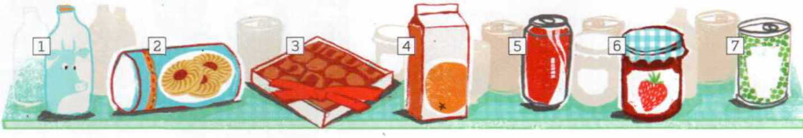



✓

Face2Face EL



[foodblogsf2010.blogspot.com](http://foodblogsf2010.blogspot.com/2010/09/pepsi-in-bottle-by-james.html)✓

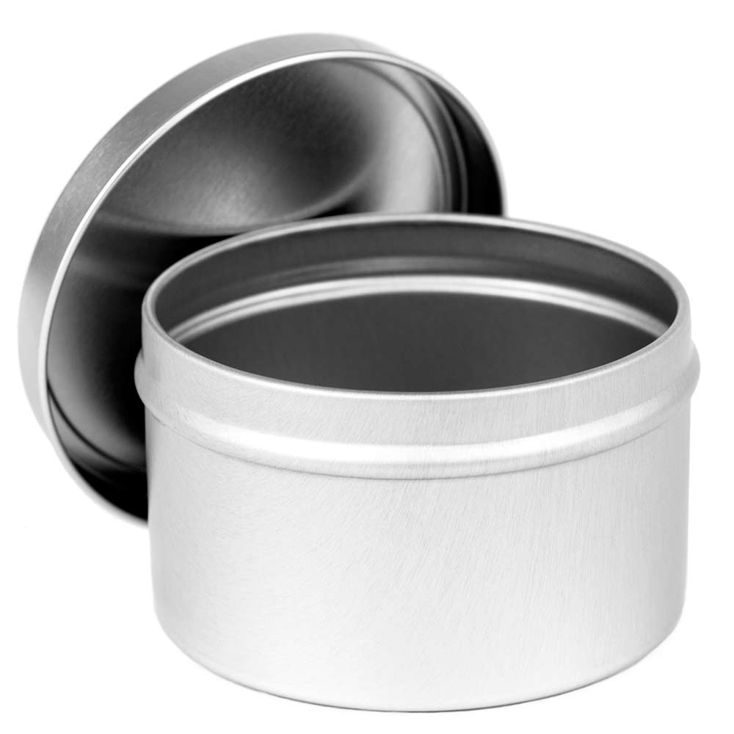

[candlescience.com](https://www.candlescience.com/containers/8oz-candle-tin/)

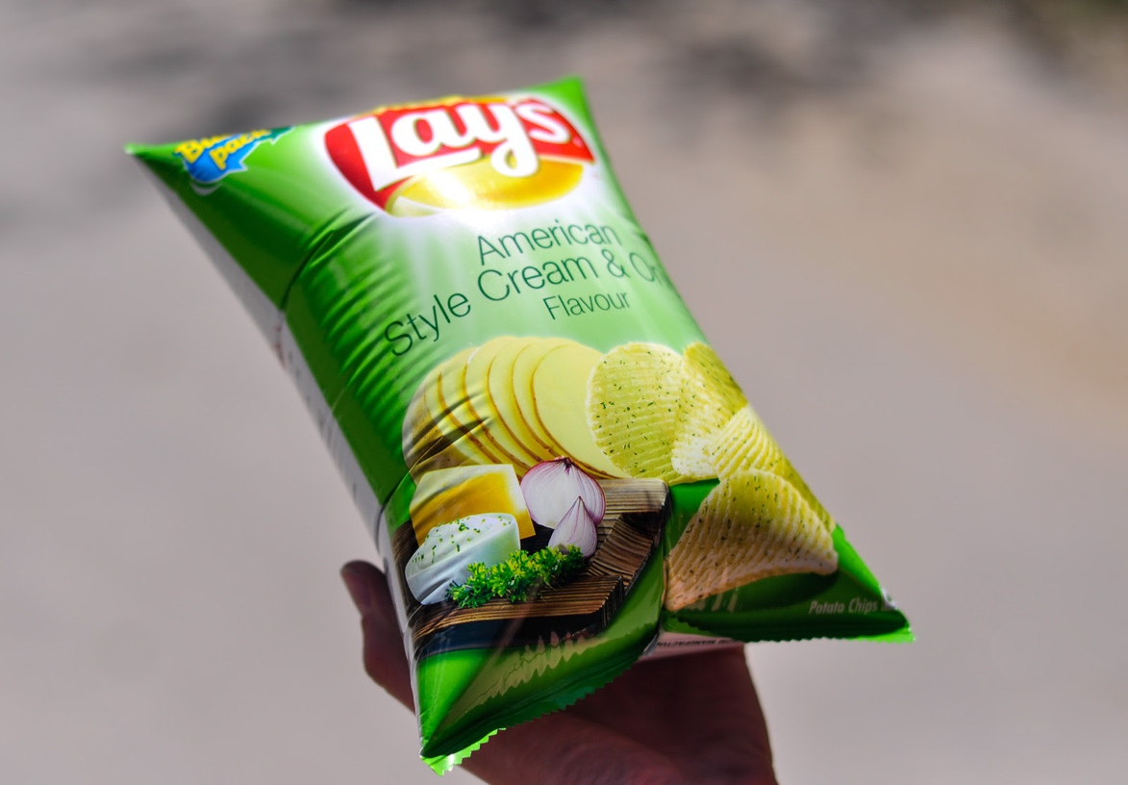

[theunrealtimes.com](http://www.theunrealtimes.com/2014/11/01/lays-chips-packets-substitute-for-balloons-in-birthday-party/)



[funnyordie.com](http://www.funnyordie.com/articles/5c1bf0686b/what-happens-60-years-after-drinking-a-can-of-coke)

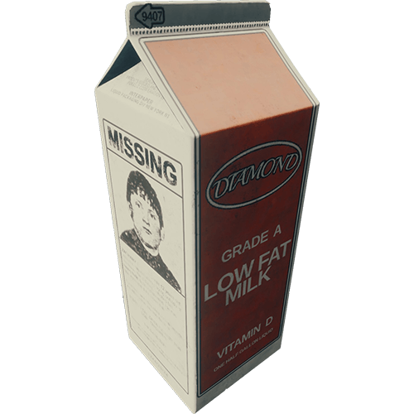

[theforest.gamepedia.com](https://theforest.gamepedia.com/Milk_Carton)



[blog.timesunion.com](http://blog.timesunion.com/opinion/americans-no-longer-on-the-move/16375/open-empty-cardboard-box-3d-illustration/)